NEW LINK:
https://digitalapps2.daera-ni.gov.uk/RMCGS/

For users who are having issues please advise the following.
In most cases this screen will appear with the word “Advanced” where it now says “Hide Advanced” once they select “Advanced” the last paragraph will appear, they just need to hit “Continue to …” and it will open up the link above.
For exceptional cases where the above does not work I would advise navigating to Microsoft Edge

Clicking the big green button on the site or where the user knows the URL typing in the old URL for the scheme
Poots launches Rural Micro Capital Grant Scheme 2022 | Department of Agriculture, Environment and Rural Affairs (daera-ni.gov.uk)

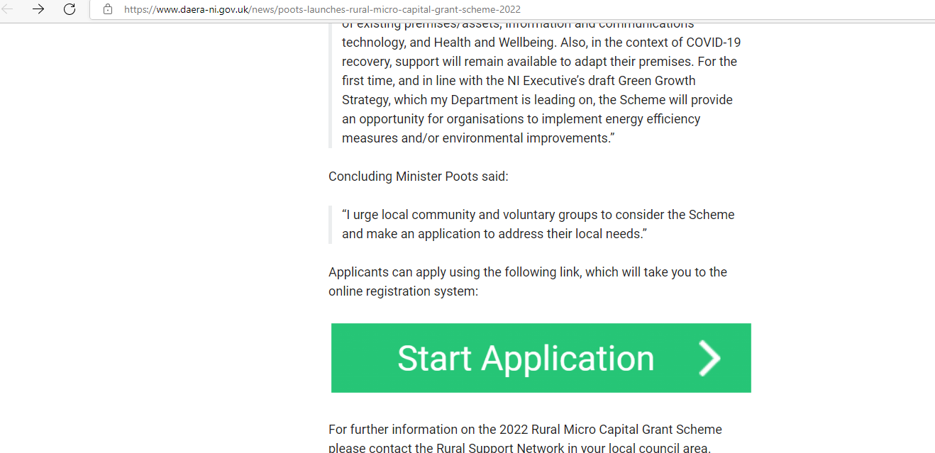
Either route will take them to the following screen:
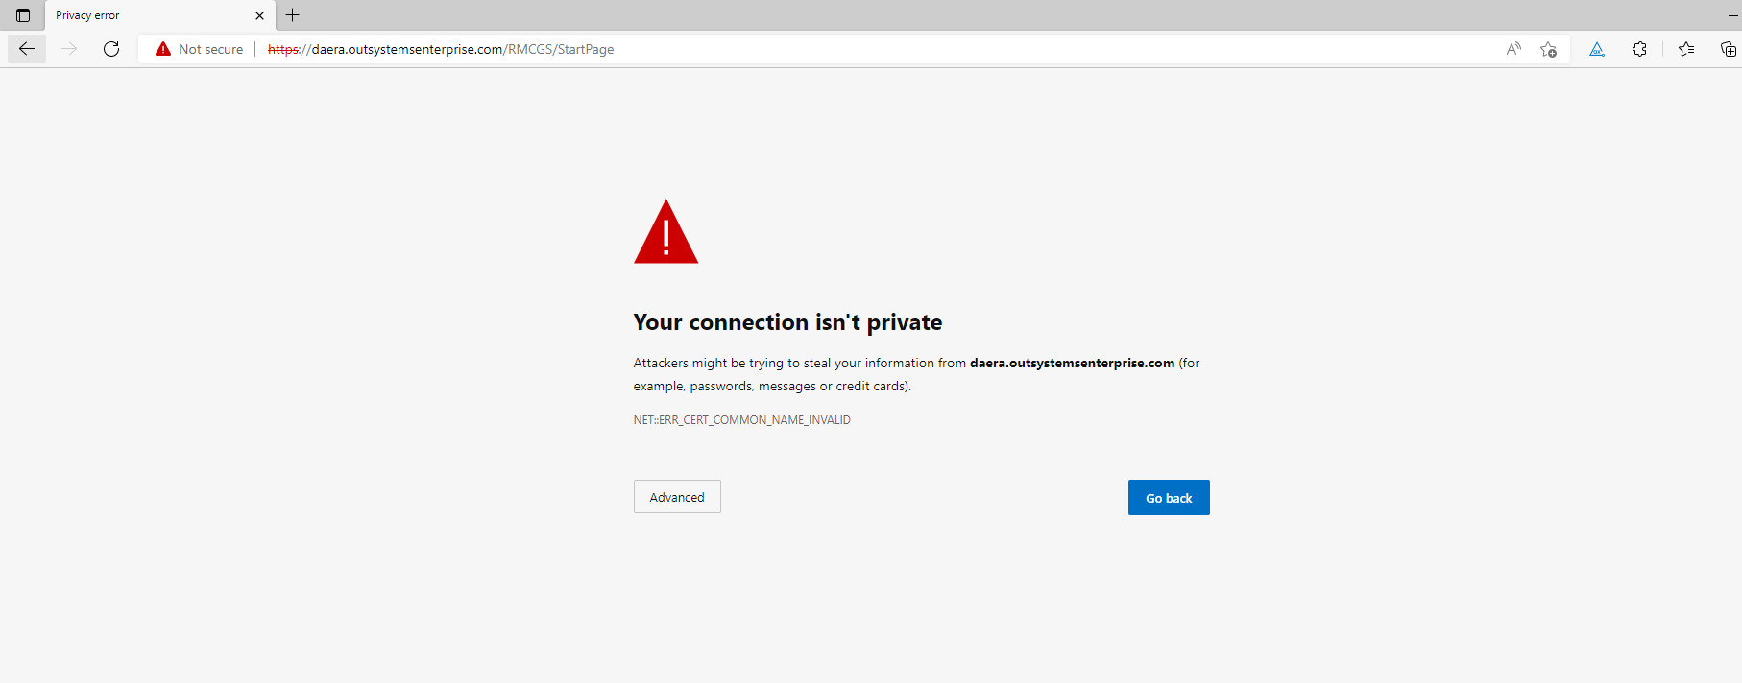
Hitting advanced here will again open up the same screen as above where they will need to hit “Contiue…”
It will open up the following and they will be able to sign back in as normal.
